**LAPORAN PRAKTIKUM 1**

**PEMROGRAMAN 4**

**Nama : Moh. Rachmat Wira Utama**

**NPM : 4513210025**

1. Membuat aplikasi project java web menggunakan Maven

Pom.xml

<?xml version="1.0" encoding="UTF-8"?>

<project xmlns="http://maven.apache.org/POM/4.0.0" xmlns:xsi="http://www.w3.org/2001/XMLSchema-instance" xsi:schemaLocation="http://maven.apache.org/POM/4.0.0 http://maven.apache.org/xsd/maven-4.0.0.xsd">

<modelVersion>4.0.0</modelVersion>

<groupId>com.mycompany</groupId>

<artifactId>praktikum-1</artifactId>

<version>1.0-SNAPSHOT</version>

<packaging>war</packaging>

<name>praktikum-1</name>

<properties> <endorsed.dir>${project.build.directory}/endorsed</endorsed.dir>

<project.build.sourceEncoding>UTF-8</project.build.sourceEncoding>

</properties>

<dependencies>

<dependency>

<groupId>javax</groupId>

<artifactId>javaee-web-api</artifactId>

<version>7.0</version>

<scope>provided</scope>

</dependency>

</dependencies>

<build>

<plugins>

<plugin>

<groupId>org.apache.maven.plugins</groupId>

<artifactId>maven-compiler-plugin</artifactId>

<version>3.1</version>

<configuration>

<source>1.7</source>

<target>1.7</target>

<compilerArguments>

<endorseddirs>${endorsed.dir}</endorseddirs>

</compilerArguments>

</configuration>

</plugin>

<plugin>

<groupId>org.apache.maven.plugins</groupId>

<artifactId>maven-war-plugin</artifactId>

<version>2.3</version>

<configuration>

<failOnMissingWebXml>false</failOnMissingWebXml>

</configuration>

</plugin>

<plugin>

<groupId>org.apache.maven.plugins</groupId>

<artifactId>maven-dependency-plugin</artifactId>

<version>2.6</version>

<executions>

<execution>

<phase>validate</phase>

<goals>

<goal>copy</goal>

</goals>

<configuration> <outputDirectory>${endorsed.dir}</outputDirectory>

<silent>true</silent>

<artifactItems>

<artifactItem>

<groupId>javax</groupId>

<artifactId>javaee-endorsed-api</artifactId>

<version>7.0</version>

<type>jar</type>

</artifactItem>

</artifactItems>

</configuration>

</execution>

</executions>

</plugin>

</plugins>

</build></project>

Index.html

<!DOCTYPE html>

<html>

<head>

<title>Pemrograman 4</title>

<meta http-equiv="Content-Type" content="text/html; charset=UTF-8">

</head>

<body>

<h1>Halo Maven!</h1>

</body>

</html>

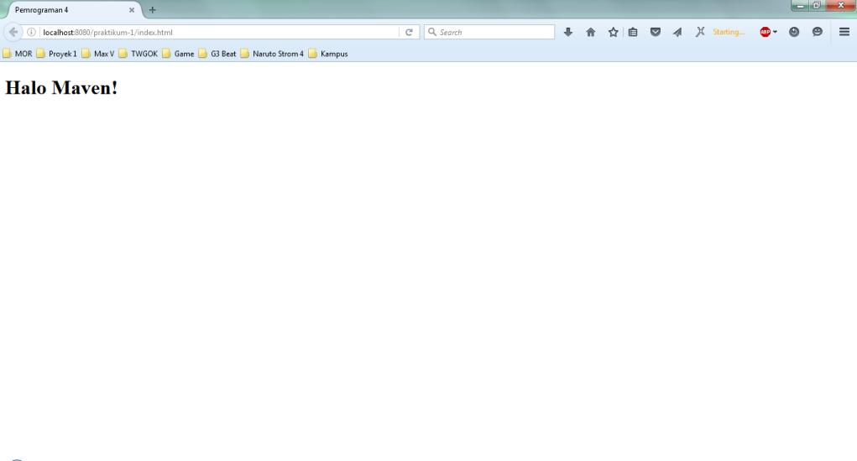

cd D:\Data D Compaq 515\IT UP 2013\Semester 6\P4\praktikum-1; "JAVA_HOME=C:\\Program Files\\Java\\jdk1.8.0_20" cmd /c "\"\"C:\\Program Files\\NetBeans 8.0.2\\java\\maven\\bin\\mvn.bat\" -Dnetbeans.deploy=true -Dnetbeans.deploy.clientUrlPart=/index.html -Dmaven.ext.class.path=\"C:\\Program Files\\NetBeans 8.0.2\\java\\maven-nblib\\netbeans-eventspy.jar\" -Dfile.encoding=UTF-8 package\""

Scanning for projects...

------------------------------------------------------------------------

Building praktikum-1 1.0-SNAPSHOT

------------------------------------------------------------------------

--- maven-dependency-plugin:2.6:copy (default) @ praktikum-1 ---

--- maven-resources-plugin:2.5:resources (default-resources) @ praktikum-1 ---

[debug] execute contextualize

Using 'UTF-8' encoding to copy filtered resources.

Copying 0 resource

--- maven-compiler-plugin:3.1:compile (default-compile) @ praktikum-1 ---

Nothing to compile - all classes are up to date

--- maven-resources-plugin:2.5:testResources (default-testResources) @ praktikum-1 ---

[debug] execute contextualize

Using 'UTF-8' encoding to copy filtered resources.

skip non existing resourceDirectory D:\Data D Compaq 515\IT UP 2013\Semester 6\P4\praktikum-1\src\test\resources

--- maven-compiler-plugin:3.1:testCompile (default-testCompile) @ praktikum-1 ---

No sources to compile

--- maven-surefire-plugin:2.10:test (default-test) @ praktikum-1 ---

No tests to run.

Surefire report directory: D:\Data D Compaq 515\IT UP 2013\Semester 6\P4\praktikum-1\target\surefire-reports

-------------------------------------------------------

T E S T S

-------------------------------------------------------

Results :

Tests run: 0, Failures: 0, Errors: 0, Skipped: 0

--- maven-war-plugin:2.3:war (default-war) @ praktikum-1 ---

Packaging webapp

Assembling webapp [praktikum-1] in [D:\Data D Compaq 515\IT UP 2013\Semester 6\P4\praktikum-1\target\praktikum-1-1.0-SNAPSHOT]

Processing war project

Copying webapp resources [D:\Data D Compaq 515\IT UP 2013\Semester 6\P4\praktikum-1\src\main\webapp]

Webapp assembled in [328 msecs]

Building war: D:\Data D Compaq 515\IT UP 2013\Semester 6\P4\praktikum-1\target\praktikum-1-1.0-SNAPSHOT.war

------------------------------------------------------------------------

BUILD SUCCESS

------------------------------------------------------------------------

Total time: 24.851s

Finished at: Fri Apr 01 10:47:52 ICT 2016

Final Memory: 12M/184M

------------------------------------------------------------------------

NetBeans: Deploying on GlassFish Server 4.1

profile mode: false

debug mode: false

force redeploy: true

Starting GlassFish Server 4.1

GlassFish Server 4.1 is running.

In-place deployment at D:\Data D Compaq 515\IT UP 2013\Semester 6\P4\praktikum-1\target\praktikum-1-1.0-SNAPSHOT

1. Membuat Java Servlet dengan mengkonversi huruf capital

HaloServlet1.java

/*

* To change this license header, choose License Headers in Project Properties.

* To change this template file, choose Tools | Templates

* and open the template in the editor.

*/

package com.mycompany.praktikum;

import java.io.IOException;

import java.io.PrintWriter;

import javax.servlet.ServletException;

import javax.servlet.annotation.WebServlet;

import javax.servlet.http.HttpServlet;

import javax.servlet.http.HttpServletRequest;

import javax.servlet.http.HttpServletResponse;

/**

*

* @author Mor

*/

@WebServlet(name = "HaloServlet1", urlPatterns = {"/HaloServlet1"})

public class HaloServlet1 extends HttpServlet {

/**

* Processes requests for both HTTP <code>GET</code> and <code>POST</code>

* methods.

*

* @param request servlet request

* @param response servlet response

* @throws ServletException if a servlet-specific error occurs

* @throws IOException if an I/O error occurs

*/

protected void processRequest(HttpServletRequest request, HttpServletResponse response)

throws ServletException, IOException {

response.setContentType("text/html;charset=UTF-8");

try (PrintWriter out = response.getWriter()) {

/* TODO output your page here. You may use following sample code. */

out.println("<!DOCTYPE html>");

out.println("<html>");

out.println("<head>");

out.println("<title>Servlet MyFirstServlet</title>");

out.println("</head>");

String Kalimat = "halo rahmat";

out.println(""+Kalimat);

// Mengubah isi String menjadi huruf besar

String besarA = Kalimat.toUpperCase();

out.println(""+besarA);

out.println("</html>");

}

}

// <editor-fold defaultstate="collapsed" desc="HttpServlet methods. Click on the + sign on the left to edit the code.">

/**

* Handles the HTTP <code>GET</code> method.

*

* @param request servlet request

* @param response servlet response

* @throws ServletException if a servlet-specific error occurs

* @throws IOException if an I/O error occurs

*/

@Override

protected void doGet(HttpServletRequest request, HttpServletResponse response)

throws ServletException, IOException {

processRequest(request, response);

}

/**

* Handles the HTTP <code>POST</code> method.

*

* @param request servlet request

* @param response servlet response

* @throws ServletException if a servlet-specific error occurs

* @throws IOException if an I/O error occurs

*/

@Override

protected void doPost(HttpServletRequest request, HttpServletResponse response)

throws ServletException, IOException {

processRequest(request, response);

}

/**

* Returns a short description of the servlet.

*

* @return a String containing servlet description

*/

@Override

public String getServletInfo() {

return "Short description";

}// </editor-fold>

}

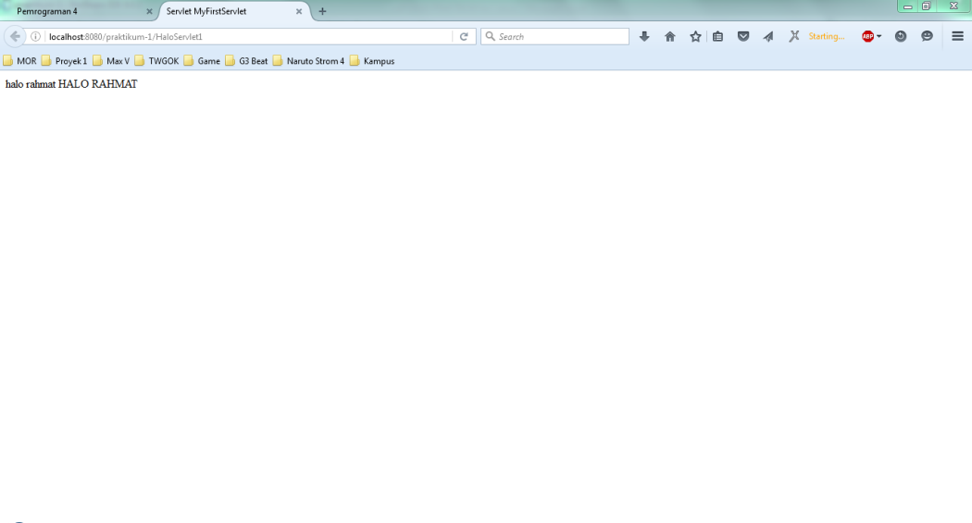

File Deploy

cd D:\Data D Compaq 515\IT UP 2013\Semester 6\P4\praktikum-1; "JAVA_HOME=C:\\Program Files\\Java\\jdk1.8.0_20" cmd /c "\"\"C:\\Program Files\\NetBeans 8.0.2\\java\\maven\\bin\\mvn.bat\" -Dnetbeans.deploy=true -Dnetbeans.deploy.clientUrlPart=/HaloServlet1 -Dmaven.ext.class.path=\"C:\\Program Files\\NetBeans 8.0.2\\java\\maven-nblib\\netbeans-eventspy.jar\" -Dfile.encoding=UTF-8 package\""

Scanning for projects...

------------------------------------------------------------------------

Building praktikum-1 1.0-SNAPSHOT

------------------------------------------------------------------------

--- maven-dependency-plugin:2.6:copy (default) @ praktikum-1 ---

--- maven-resources-plugin:2.5:resources (default-resources) @ praktikum-1 ---

[debug] execute contextualize

Using 'UTF-8' encoding to copy filtered resources.

Copying 0 resource

--- maven-compiler-plugin:3.1:compile (default-compile) @ praktikum-1 ---

Nothing to compile - all classes are up to date

--- maven-resources-plugin:2.5:testResources (default-testResources) @ praktikum-1 ---

[debug] execute contextualize

Using 'UTF-8' encoding to copy filtered resources.

skip non existing resourceDirectory D:\Data D Compaq 515\IT UP 2013\Semester 6\P4\praktikum-1\src\test\resources

--- maven-compiler-plugin:3.1:testCompile (default-testCompile) @ praktikum-1 ---

No sources to compile

--- maven-surefire-plugin:2.10:test (default-test) @ praktikum-1 ---

Surefire report directory: D:\Data D Compaq 515\IT UP 2013\Semester 6\P4\praktikum-1\target\surefire-reports

-------------------------------------------------------

T E S T S

-------------------------------------------------------

Results :

Tests run: 0, Failures: 0, Errors: 0, Skipped: 0

--- maven-war-plugin:2.3:war (default-war) @ praktikum-1 ---

Packaging webapp

Assembling webapp [praktikum-1] in [D:\Data D Compaq 515\IT UP 2013\Semester 6\P4\praktikum-1\target\praktikum-1-1.0-SNAPSHOT]

Processing war project

Copying webapp resources [D:\Data D Compaq 515\IT UP 2013\Semester 6\P4\praktikum-1\src\main\webapp]

Webapp assembled in [47 msecs]

Building war: D:\Data D Compaq 515\IT UP 2013\Semester 6\P4\praktikum-1\target\praktikum-1-1.0-SNAPSHOT.war

------------------------------------------------------------------------

BUILD SUCCESS

------------------------------------------------------------------------

Total time: 4.804s

Finished at: Fri Apr 01 14:31:38 ICT 2016

Final Memory: 13M/232M

------------------------------------------------------------------------

NetBeans: Deploying on GlassFish Server 4.1

profile mode: false

debug mode: false

force redeploy: true

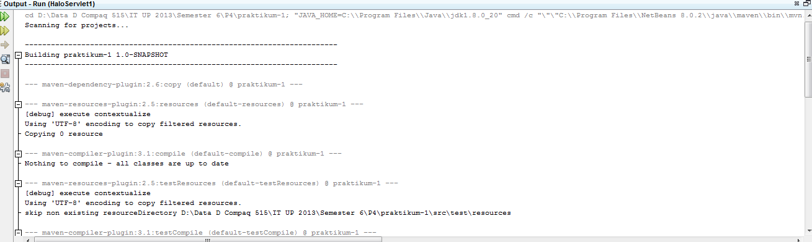

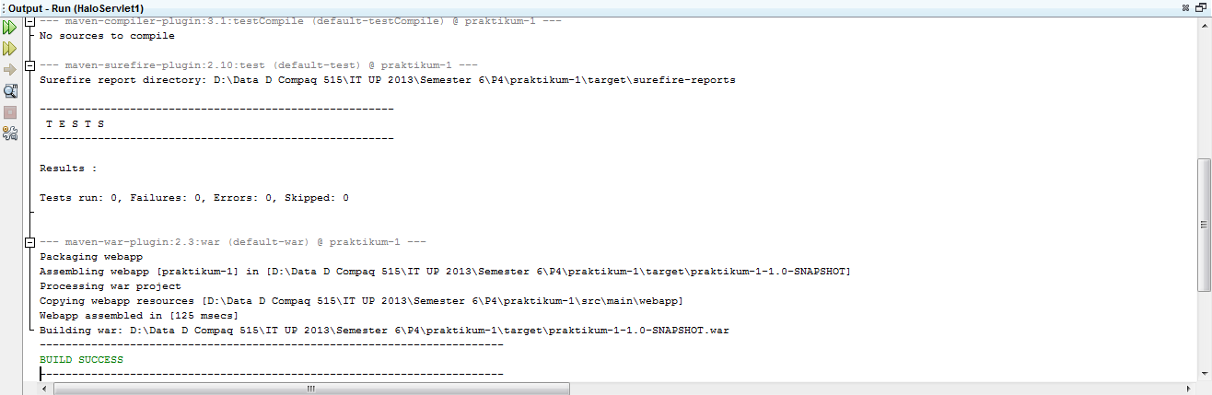

File Undeploy

Undeploying ...

In-place deployment at D:\Data D Compaq 515\IT UP 2013\Semester 6\P4\praktikum-1\target\praktikum-1-1.0-SNAPSHOT

D:\Data D Compaq 515\IT UP 2013\Semester 6\P4\praktikum-1\undeploy.PNG